**Smart Hospital Prediction and Consultation System**



An

Software Engineering Course Project Report

in partial fulfilment of the degree

**Bachelor of Technology**

**in**

**Computer Science & Engineering**

B.Karthik 2203A51337

E.Sidhardha Reddy 2203A51281

T.Neeraj 2203A51262

**Submitted to**

# DEPARTMENT OF COMPUTER SCIENCE & ENGINEERING

**CERTIFICATE**

This is to certify that the **Software Engineering - Course Project** Report entitled **“Smart Hospital Prediction and Consultation System”** is a record of bonafide work carried out by the student B.Karthik, E.Sidhardha Reddy, T.Neeraj bearing Roll No(s) 2203A51337,2203A51281,2203A51262 during the academic year 2024 in partial fulfillment of the award of the degree of ***Bachelor of Technology*** in **Computer Science & Engineering** by the SR University, Anantsagar.

**Superviser Head of the Department**

Dr. Deepan s Dr. M. Sheshikala

Asst. Professor Assoc. Prof .& HOD (CSE)

SR University SR University

**Index**

**1 Problem Statement 4**

**2 Introduction 4**

1.1 Purpose 4

1.2 Scope 4

1.3 Technologies to be used 5

1.4 Overview 5

**2 Overall Description 5**

2.1 Product Perspective 5

2.2 Software Interface 6

2.3 Hardware Interface 6

2.4 Interface Diagrams 6

2.5 System Functions 7

2.6 User Characteristics 7

2.7 Constraints 8

2.8 Assumptions and Dependencies 8

**3 ER Diagram 8**

**4 Class Diagram 9**

**5 Use Case Diagram 9**

**6 Sequence Diagram 10**

**7 State Chart Diagram 10**

**8 Activity Diagram 11**

**9 Collaboration Diagram 11**

**10 Deployment Diagram 12**

**11 Component Diagram 12**

**12 Interaction Overview Diagram 13**

**13 Conclusion 13**

**Problem Statement:**

“The healthcare industry is facing challenges in providing efficient and prompt services to patients. Patients often struggle to diagnose their symptoms and find the right specialist for consultation. The process of booking appointments is also cumbersome and time-consuming. There is a need for a comprehensive solution that can predict health conditions based on symptoms, recommend specialists, and facilitate online consultations. The solution should be user-friendly and serve as a reliable tool for both patients and healthcare professionals. This forms the basis for the development of the ‘Smart Health Prediction and Consultation Application’.”

**1.Introduction:**

**1.1.Purpose:**

This document gives a brief description about the software requirement speciﬁcations (SRS), both functional and nonfunctional, for the Smart Health Prediction and Consultation Application, version1.0, developed in Semester 6 as part of Software Engineering Course. This document will illustrate and provide the overall description, purpose, usage, and detail the development concepts of this system. Additionally, this document will serve as a tool for the development team and software testers involved in this project, to better understand the full scope of this application. The purpose of this software application is to provide a simple, easy to use system which helps them to diagnose their disease. Also they can book an appointment and consult a specialized doctor online using this application.

**1.2.Scope:**

Smart Health Prediction and Consultation system allows users to get instant guidance on their health issues through an intelligent health care system online. Users can give in their various symptoms and the issues they are facing. The application then takes the user's symptoms as inputs to check for various illnesses that could be associated with it using a prediction algorithm. The system also provides the users with suggestions for doctors in their region whom they can consult for treatment of their predicted illness. Users can also opt for online consultation, by making an initial consultation fee payment online and can schedule an online appointment with the concerned doctor. The product will be available for use as a web application and is intended to be simple and easy to use.

**1.3.Technologies to be used:**

**Software Requirement Specification (SRS) Using ER and DFD:**

* **Entity-Relationship (ER) Diagram:** An ER diagram will be used to illustrate the logical structure of the database used by the Smart Health Prediction and Consultation Application. It will include entities such as User, Symptom, Disease, Specialist, Appointment, and Consultation, along with their relationships.
* **Data Flow Diagram (DFD):** A DFD will be used to represent the flow of data within the system. It will show how inputs from the user (like symptoms) are processed (using the prediction algorithm) to generate outputs (like disease predictions and specialist recommendations).

**1.4.Overview**

The ‘Smart Health Prediction and Consultation Application’ is an innovative solution designed to enhance healthcare services. It assists patients in diagnosing symptoms, finding specialists, and facilitating online consultations. The application uses a prediction algorithm to analyze user-inputted symptoms and predict potential health conditions. It recommends specialists for further consultation and simplifies the appointment booking process. Developed as part of a Software Engineering Course, the application is user-friendly and serves as a reliable tool for patients and healthcare professionals. It employs HTML, CSS, and JavaScript for the front-end, NodeJS for the back-end, and MySQL for the database. The application is accessible via any web browser that supports these technologies and can be used on personal computers, laptops, and smartphones without requiring any specialized hardware. This comprehensive solution aims to streamline healthcare services, making them more efficient and accessible.

**2.Overall Description**

**2.1. Product Perspective:**

The ﬁnal result of this project is a product that is a member of the “health and wellness” application category. Some examples of applications in this family are: Healthians, Health Map, Docs app ,WayuMD and so on. This health application will be a self -contained product that encompasses features that will help the consumer to an easier and more eﬃcient way to live a healthier life. The main features of the software application include:

●Prediction of the disease based on symptoms

●Suggestion of specialised doctors

-Based on the predicted disease, the system suggests available doctors in their region for consultation along with their contact information

●Payment portal

-The user makes payments to the admin.

-The admin forwards the payment to the doctor.

●Schedule an appointment for online consultation

-The admin schedules a time for the patient for online consultation with the selected doctor.

. ●Online consultation portal

-Video call conferencing with the doctor.

**2.2 Software Interface**

**Technologies Used:**

- **Front end:** HTML, CSS, JavaScript

- **Back end**: NodeJS

- **Database**: MySQL

**2.3 Hardware Interface**

The application is accessible on personal computers, laptops, smartphones, or similar devices. It doesn't require specialized hardware.

**2.4 Interface Diagrams:**

**Entity-Relationship (ER) Diagram:**

An ER diagram will illustrate the logical structure of the database. It includes entities such as User, Symptom, Disease, Specialist, Appointment, and Consultation, along with their relationships.

**Data Flow Diagram (DFD):**

A DFD will represent the flow of data within the system. It will show how inputs from the user (like symptoms) are processed using the prediction algorithm to generate outputs like disease predictions and specialist recommendations.

**2.5 System Functions**

**Key Features:**

1. **Prediction of diseases based on symptoms:**

- Users input symptoms, and the application employs a prediction algorithm to suggest potential health conditions.

**2. Suggestion of specialized doctors:**

- Based on predicted diseases, the system suggests available doctors in the user's region for consultation along with their contact information.

**3. Payment portal:**

- Users make payments to the admin, who forwards the payment to the doctor.

**4. Schedule an appointment for online consultation:**

- The admin schedules a time for the patient for online consultation with the selected doctor.

**5. Online consultation portal:**

- Enables video call conferencing with the doctor.

**2.6 User Characteristics**

**User Classes:**

**1. Patient:**

- Can log in and input symptoms for disease prediction.

- Receives suggestions for specialized doctors.

- Makes payments for consultations.

**2. Doctor:**

- Receives patient reports and information on scheduled online consultations.

**3. Admin:**

- Manages details on diseases, patients, doctors, and payments.

**2.7 Constraints**

**1. Accuracy Dependency:**

- The accuracy of disease prediction depends on the clarity of specified symptoms.

**2. Connectivity Issues:**

- Poor internet connectivity may affect online consultations.

**3. Limitations in Physical Examination:**

- Online consultations lack physical examination using various medical equipment such as stethoscopes, thermometers, etc.

**2.8 Assumptions and Dependencies**

**Assumptions:**

- Users have a valid internet connection at all times during the use of the application.

- Users are aware of the common functionalities of a web application.

- Users can make payment online if required and have access to at least one of the different modes of online payment available.

**Dependencies:**

- The correct operation between the application and MySQL databases.

- Timely interaction from the admin’s side to ensure the smooth running and functioning of the application at all times.

**3.ER Diagram**

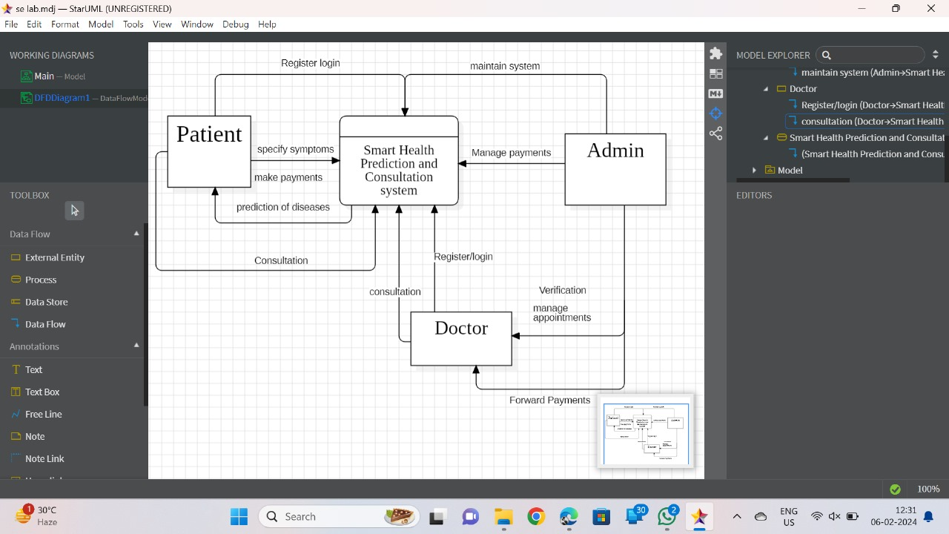An ER diagram will illustrate the logical structure of the database. It includes entities such as User, Symptom, Disease, Specialist, Appointment, and Consultation, along with their relationships.

**4.Class Diagram:**

The Class Diagram for the Smart Health Prediction and Consultation Application illustrates the various classes and their relationships in the system. It includes classes such as User, Symptom, Disease, Specialist, Appointment, and Consultation. These classes represent the key entities and concepts within the application and their associations.

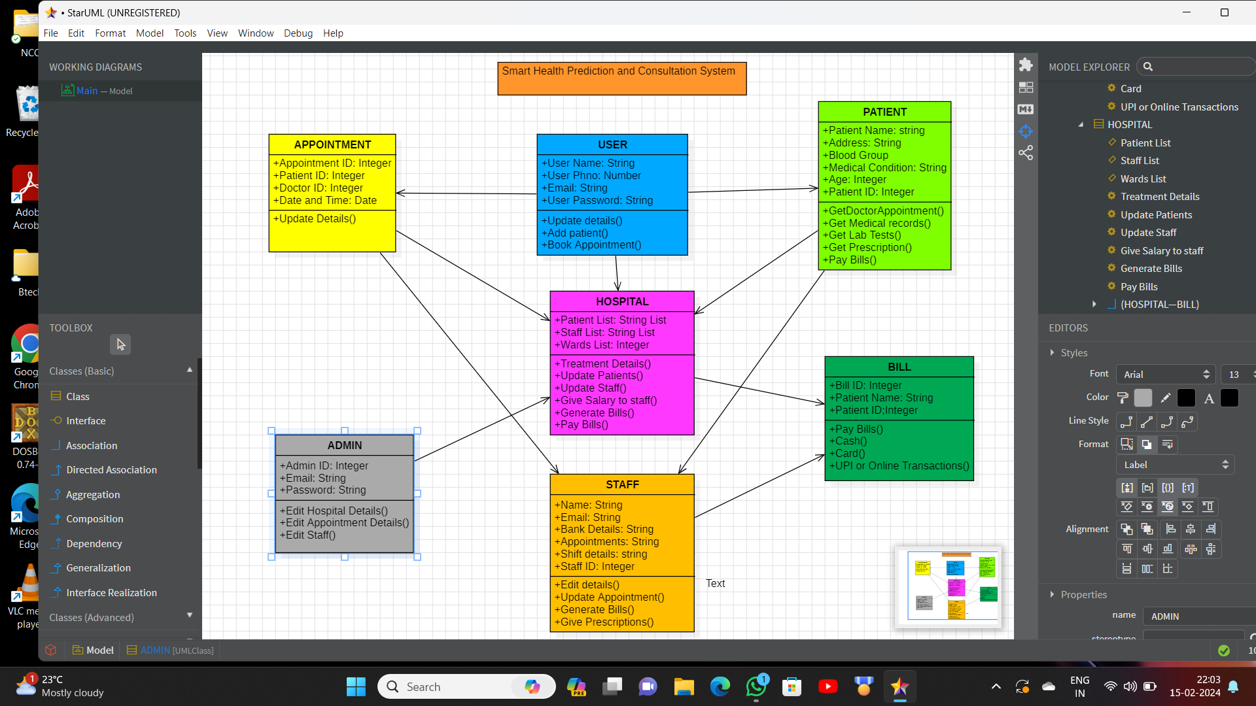

**5.Use Case Diagram:**

The Use Case Diagram provides a visual representation of the different actors and their interactions with the system. Actors include Patient, Doctor, and Admin, while use cases represent various functionalities such as Disease Prediction, Doctor Recommendation, Payment Processing, Appointment Scheduling, and Online Consultation

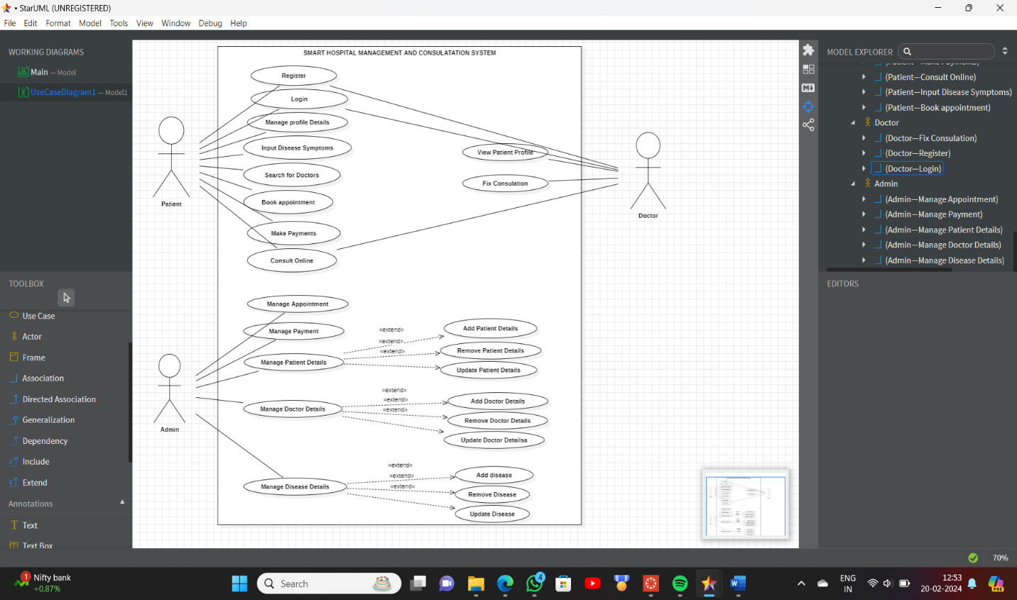

**6.Sequence Diagram**

The Sequence Diagram captures the interactions between different components of the system over time. It shows the flow of messages between actors such as Patient, Admin, and Doctor during activities like Registration, Login, Symptom Input, Disease Prediction, Doctor Recommendation, Appointment Booking, Payment Processing, and Online Consultation.

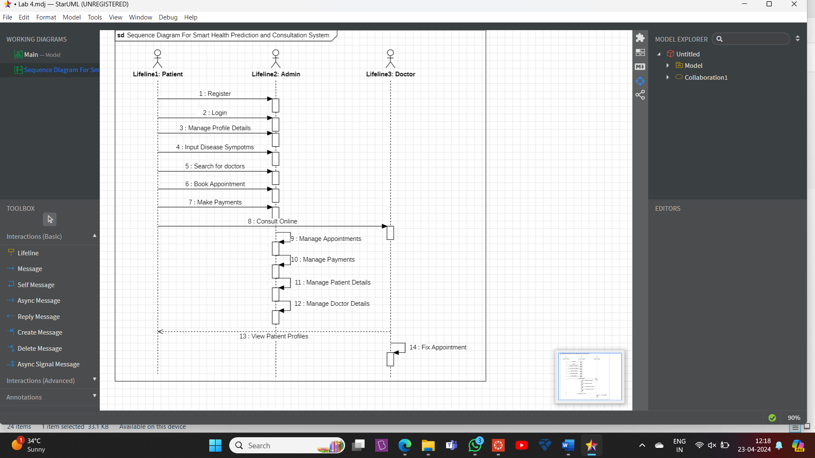

**7.State Chart Diagram**

The State Chart Diagram models the different states that objects within the system can transition through in response to events. It represents the lifecycle of entities like Appointment and Consultation, depicting states such as Scheduled, In Progress, Completed, and Cancelled.

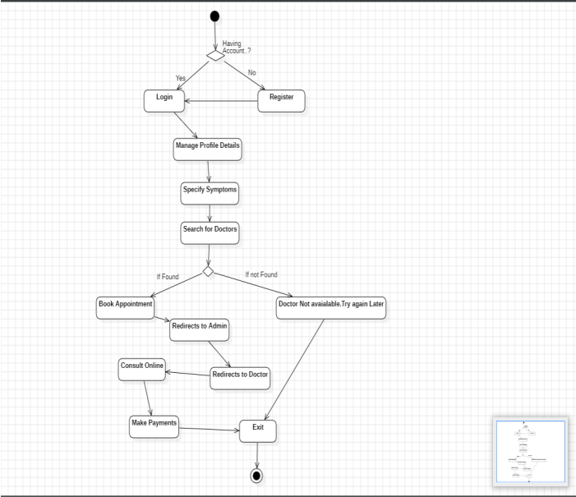

**8.Activity Diagram**

The Activity Diagram shows a smart hospital system for patients to register, manage health, book appointments with doctors found by the system, consult online or in-person, and receive prescriptions. Admins can also manage patient/doctor details and appointments.

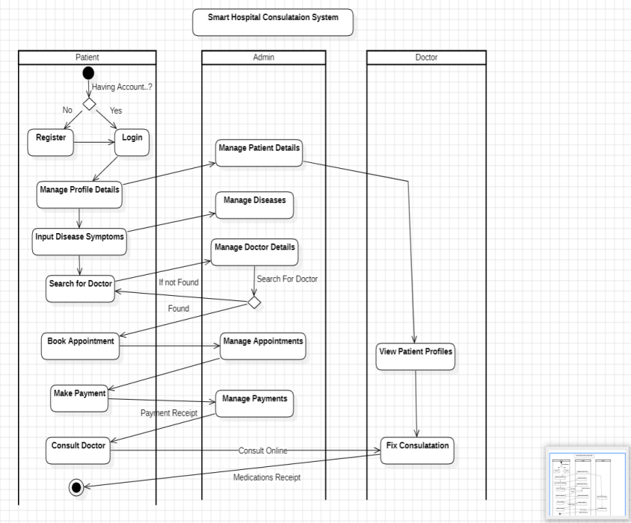

**9.Collaboration Diagram**

A collaboration diagram shows objects working together. Here, objects like "Patient" and "Doctor" send messages to each other to achieve a task. It visualizes how patients, doctors, and the system interact for appointments. Patients request doctors, book appointments, and pay. Doctors manage schedules and consult. The system connects them and manages details.

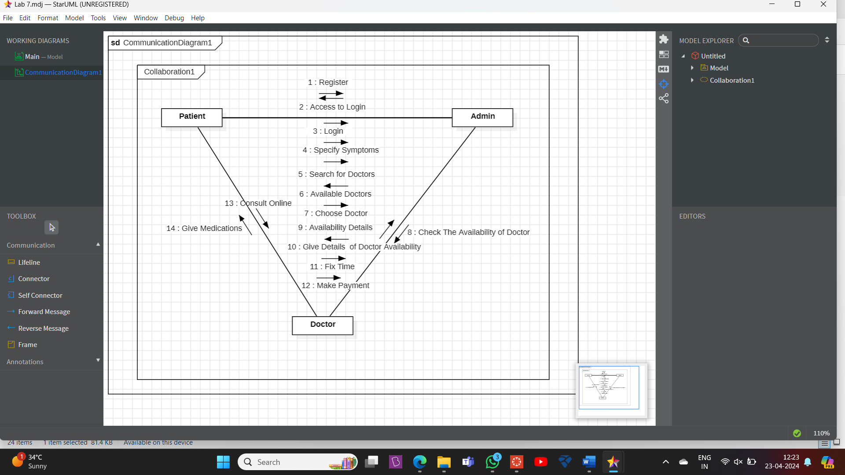

**10.Deployment Diagram**

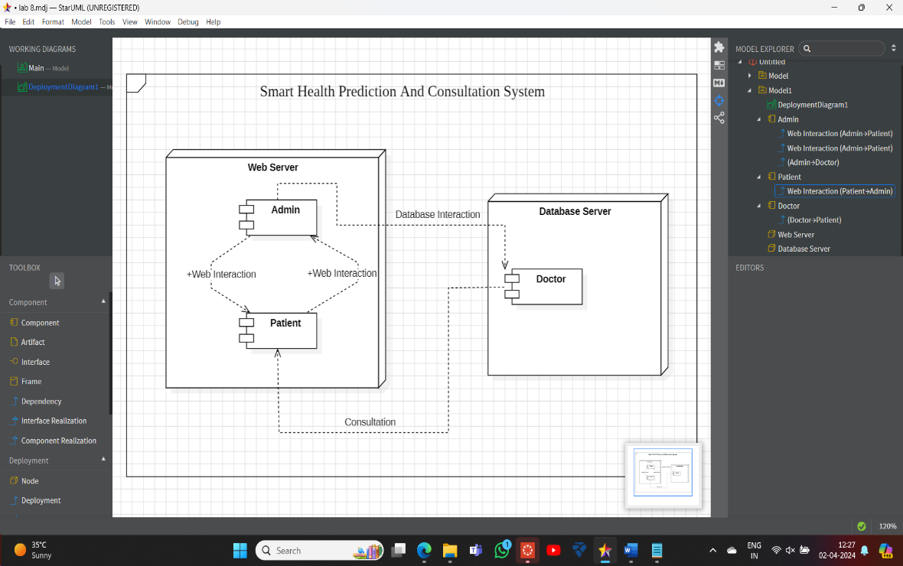The deployment diagram shows the system’s physical architecture. Software components run on a web server and a database server. Patients and doctors interact through a web interface.

**11.Component Diagram**

The component diagram shows the system’s building blocks like “Patient” and “Doctor” and their connections. Arrows show how components rely on each other. For instance, the “Book Appointment” component depends on both “Patient” and “Doctor” components.

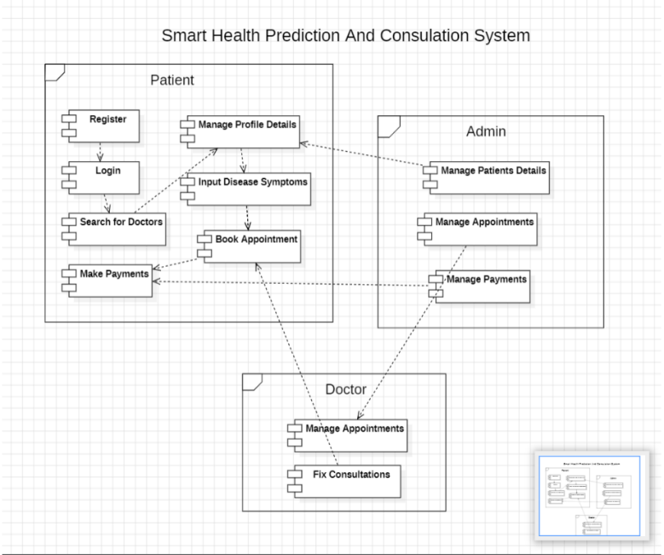

**12.Interaction Overview Diagram**

The diagram shows how patients register, manage health data, find doctors, book appointments, consult doctors (online or in-person), and receive prescriptions. Admins can also manage user details and appointments.

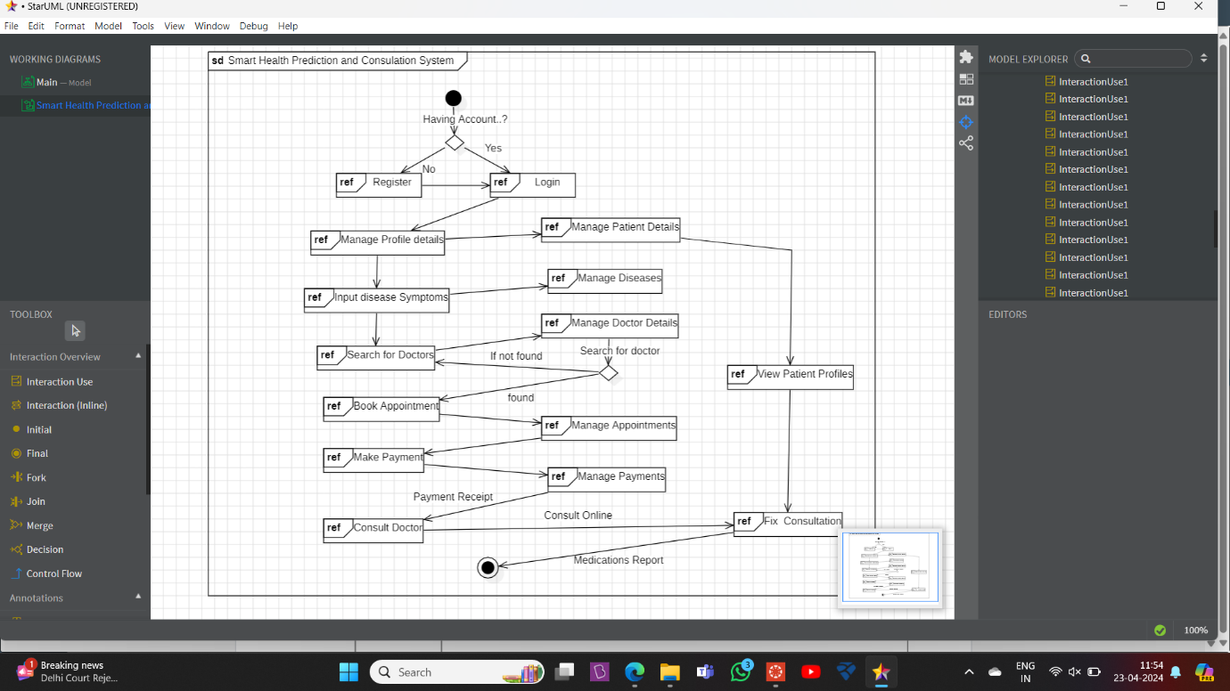

**13. Conclusion:**

The Smart Health Prediction and Consultation System aim to revolutionize healthcare services by providing an efficient, user-friendly platform. With features such as symptom-based disease prediction, doctor suggestions, online consultations, and seamless payment processing, the application seeks to bridge the gap between patients and healthcare professionals. The comprehensive solution is designed to streamline healthcare services, making them more efficient and accessible.